Creation Care

Action and Prayer: April 2024

“The Son of God created the world…to communicate himself in an image of his own excellency…He communicates a sort of shadow…of his excellencies…so that when we are delighted with flowery meadows and gentle breezes…we may consider that we see only the emanation of the sweet benevolence of Jesus Christ”: Jonathan Edwards.

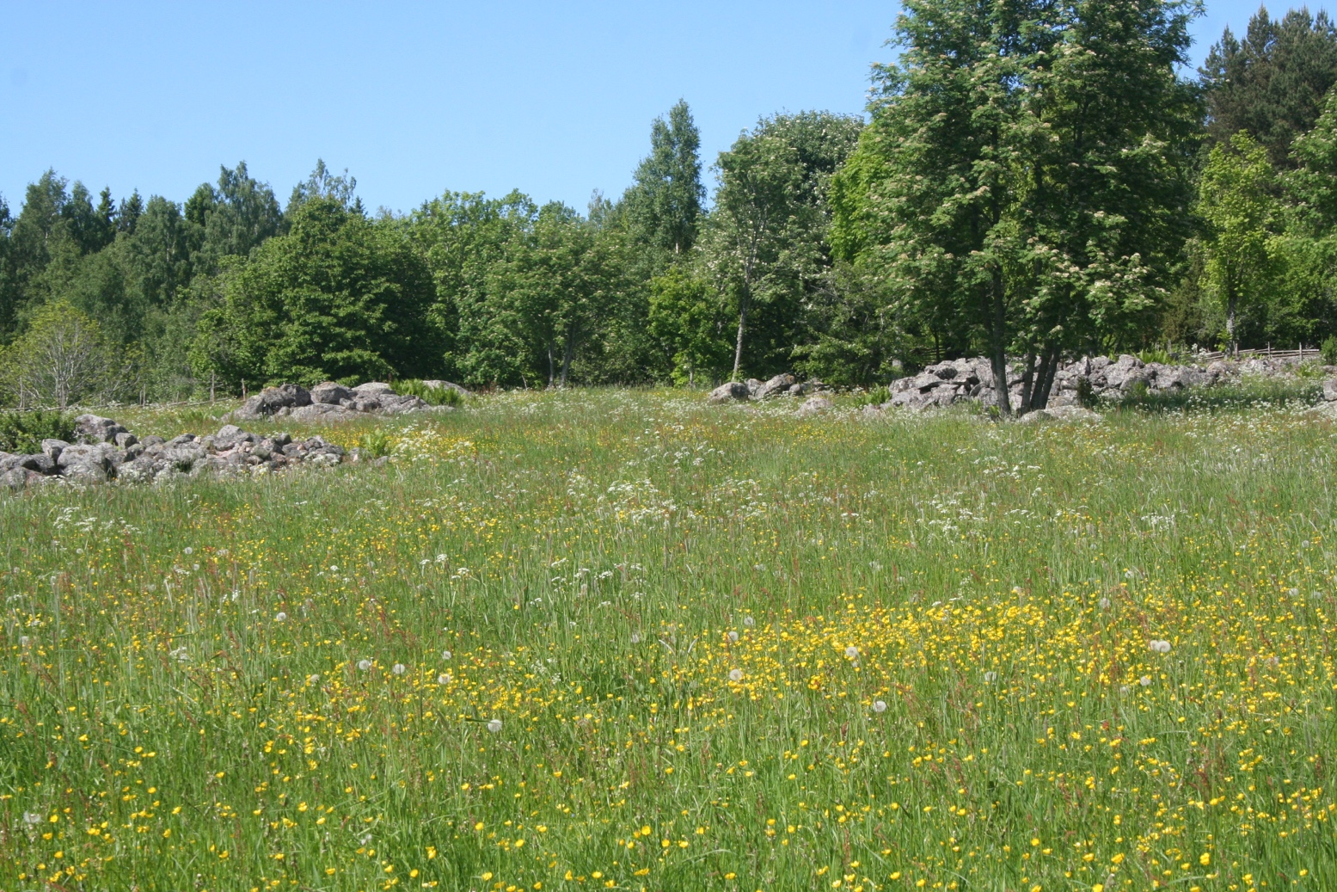
Just transition
In recent weeks, farmers across Europe, including in Wales, have attracted attention by protesting against changes to the way governments support farming. In the UK, this reflects a movement towards a large, post-Brexit decrease in subsidies and a shift to providing ‘public money for public goods’. Governments have realised that land use needs to be revised to deliver net zero carbon and increase biodiversity. Each protest focused on particular policy issues. But underlying all these protests is concern that the costs of environmental improvements are being unfairly borne by farmers. These protests underline how important it is to ensure that moving to a greener future is a just transition for everyone involved. Colin Beale, A Rocha UK Trustee and Professor of Ecology and Conservation at the University of York
PRAY
Creator God, we think of the smallest of your creations. As fragile insects emerge from dormancy and start to forage we are reminded of the precariousness of life. We lament the delicate cycles of nature which are being destroyed by human activity. We ask for opportunities to boost local populations of dragon-flies, damselflies, butterflies, moths and bees
Growing Hope in Mozambique (GH): please continue to pray for Janet Pythian visiting Mozambique until May to teach practical ways to care for God’s creation.
ACT
Fit more active travel into your day and daily routine. Re-evaluate your journeys: explore walking or cycling options, or modify your route to include some form of active travel, i.e. disembark a stop early and complete the remaining part of your journey on foot, indulge in a leisurely stroll, or opt for a bike ride along a cyclist-friendly route. Consider connecting with your local Ramblers or cycling group for shared experiences. Use the extra steps or the changed travel arrangements as a prompt to pray for God’s creation, nature’s preservation and the reduction in fossil fuel usage.

